Include a Charity Campaign Strategy 2023
Helen BEEBY, CAMPAIGN DIRECTOR
Include a Charity
2023 Strategy

The strategy for Include a Charity is reviewed and revised each year. The 2023 Strategy builds on gains made in 2022 which entailed strengthening offerings and value for members, broader public-facing marketing of the Include a Charity brand (within the FIA portfolio) and widening the scope of government policy and sector influence.

Purpose and Strategic Intent
The core purpose of Include a Charity (IAC) continues to be a social and behavioural change campaign encouraging the Australian community to consider, and confirm, leaving a gift to a charitable cause in their Will. Our remit is also to support and develop the knowledge, experience and skill sets of those in gifts in Wills fundraising sector in Australia. This latter focus also underpins and feeds into the social and behavioural change directive. IAC will continue to develop advocacy for change and best practice with government and estate planning professionals to help and support Include a Charity members and campaign objectives.

Campaign Objectives 2023
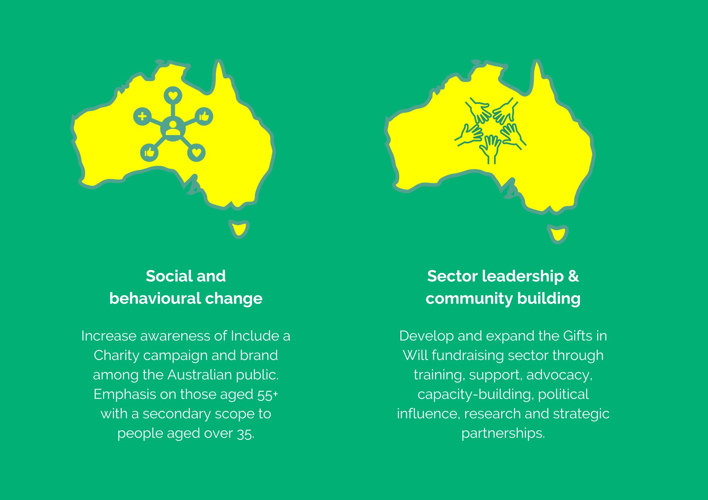

Aims and activities
Social & Behavioural Change  Include a Charity will build on its remit to increase the number of Australians who consider – and commit - to leaving a charitable gift in their Will to increase the volume and value of gifts in Will revenue.  We will do this by:  - Expanding year-round marketing, publicity and exposure to the Include a Charity brand through social media, blog posts, print media articles, podcasts, online portals, state Expo Days/Wills Weeks & the IAC website.  - Developing and delivering a compelling campaign for Include a Charity Week (Sept 4-10) capitalising on the 2021/22 campaigns and messaging.  - Drive marketing exposure and policy influence through the Wills & Legal Task Force and its sub committees.  - Providing training and ongoing professional development for gifts in Wills fundraisers to achieve improved marketing results.  - Build on the sub-campaign to influence estate planners and other legal professionals – and grow IAC website register.  - Promote the IAC website to educate and support Australians who are considering, or choosing, to leave a gift in their Will to increase the volume and value of income from gifts in Wills.  - Partner with Philanthropy Australia to engage with and lobby parliamentarians on the need for policy changes and increased investment in gifts in Wills.  - Work closely with parent organisation Fundraising Institute Australia to develop and deliver components of the Include a Charity campaign for mutual benefit and growth. |  | Sector Leadership & Community Building  Include a Charity will encourage a cohesive, partnership approach to gifts in Wills fundraising in Australia and the development of community in the sector.  We will do this by:  - Delivering training days, webinars, general discussion forums, networking events and other activities which facilitate knowledge sharing among IAC members and the community.  - Delivering a useful and successful one-day virtual conference for IAC members and paying attendees.  - Driving traffic to member causes through year-round marketing support – and specifically in IAC Week (Sept 4-10).  - Further development and re-design of IAC website for Member Portal usability and public access and navigation.  - Investing in research projects, results and outcomes for charities and boards to increase investment in Gifts in Wills fundraising.  - Expanding strategic partnerships with collegiate sector organisations and international consortiums.  - Collaborate with Philanthropy Australia to engage with/lobby parliamentarians on the need for policy changes and increased investment in gifts in Wills  - Conduct a yearly supporter survey to ensure Include a Charity meets the needs of and delivers value to IAC members.  - Supporting advanced best-practice knowledge around the channel of gifts in Wills fundraising and administration.  - Build on the sub-campaign to influence estate planners and other legal professionals; and grow IAC website register.

Target
- Primary focus - Australians aged 55+ – primarily with no children; secondary with children.
- Secondary focus – Australians aged 35+ - for long-term vision, to capitalise on online will audiences and reflect intergenerational influence.
- Broadening demographic and profile of audience to reflect multi-cultural Australia.
- New charitable organisations (especially in markets traditionally under-represented) to be part of the campaign to increase its influence and develop their own programs.
- Estate planning professionals and influencing bodies
- Policymakers and government ministries.

Key Performance Indicators
- Successful delivery with measurable data and statistics:
a) Include a Charity Week: Audience reach to exceed 15 million with >200 broadcast media segments.
b) Include a Charity One-Day Conference - >200 attendees and >50 feedback survey responses.
c) Year-round public relations and marketing activities – Audience reach (socials/online/print) and website views to exceed 5 million.
- Minimum of two large-scale research projects selected, undertaken and delivered to provide important resources for members and avenues for both PR and leadership in the GiW sector.
- Measurable influence and impact on estate planning sector and government policy:
a) Double number of solicitors on IAC website register
b) 3-5 articles to come out of Wills & Legal Task Force and used in legal/govt. media forums.
- Membership and supporter survey responses that show:
  - 10-15% increase in IAC members.
  - 10-20% increase in member satisfaction of Include a Charity.
- Member activities delivered: See calendar below.

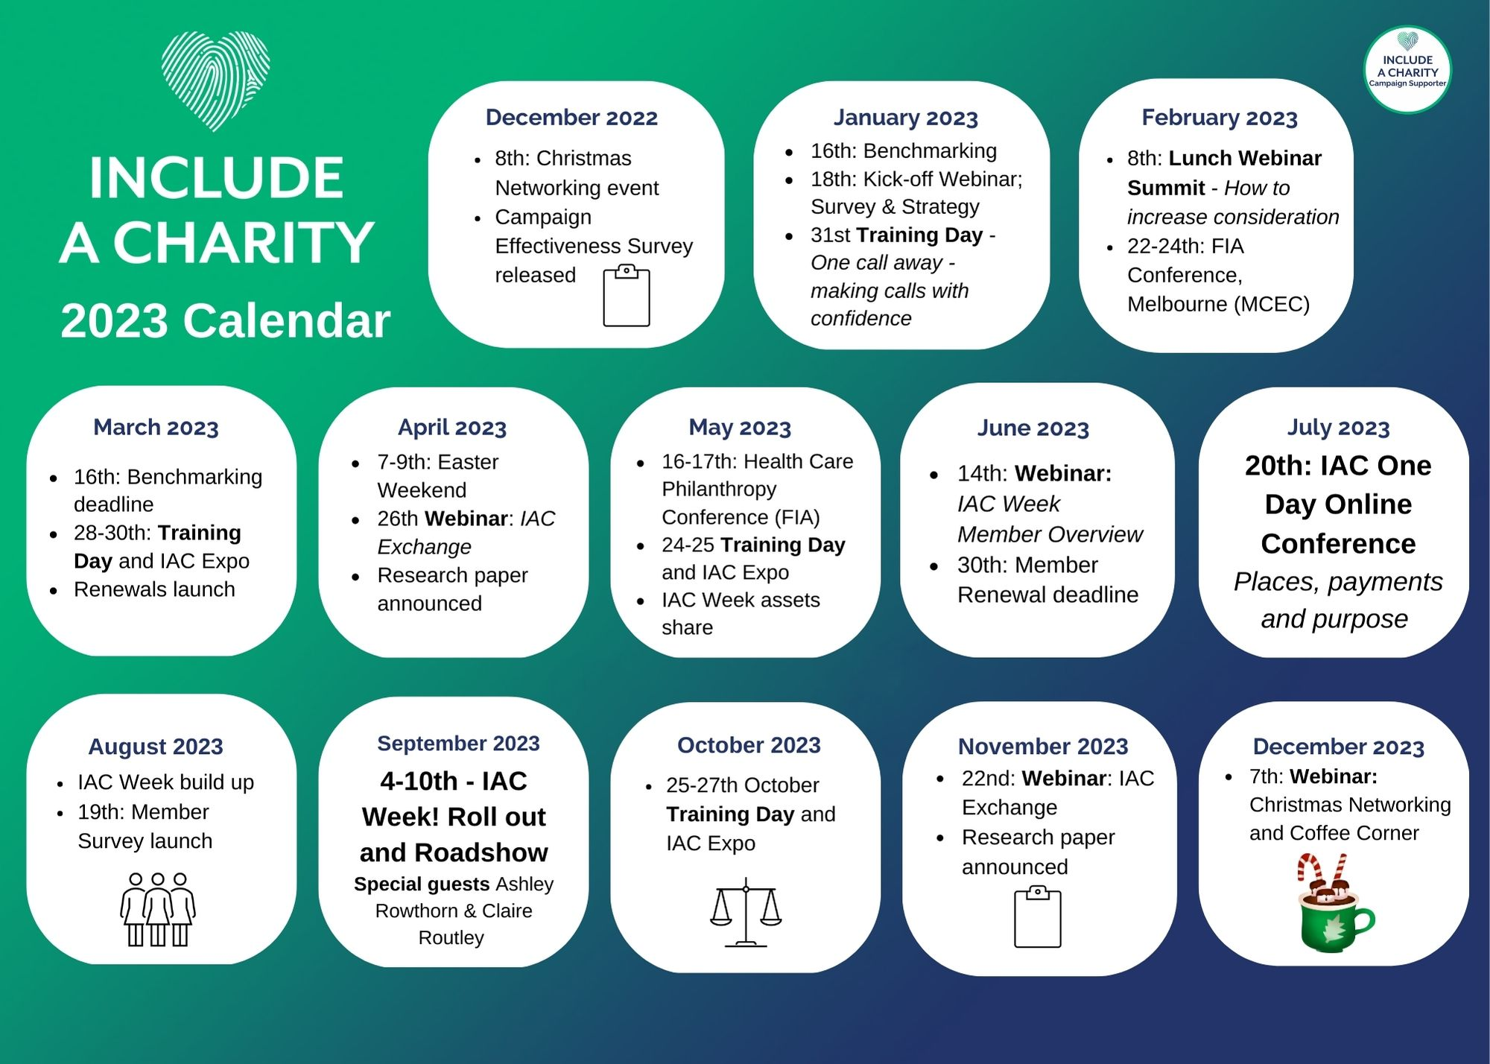

- Member Updates - twice a month.

